Fig 2

Experiment 2: Impact of Constraints
Goal: Demonstrate that the proposed method successfully minimizes constraint violations to zero, unlike the baseline Eisenberg-Gale solver.

Figure 2: Feasibility and Constraint Violation
- Y-axis: Maximum Constraint Violation $\max_i \|\max(0, \mathbf{A}_i \mathbf{x}_i - \mathbf{b}_i)\|_\infty$.
- Description: The plot compares the violation norm over iterations.
  - Baseline (Gray Dashed): Decreases initially but plateaus at a positive value, indicating it has converged to an infeasible solution.
  - Proposed (Green Solid): Smoothly decays to a smaller value, ideally 0, indicating a feasible solution.
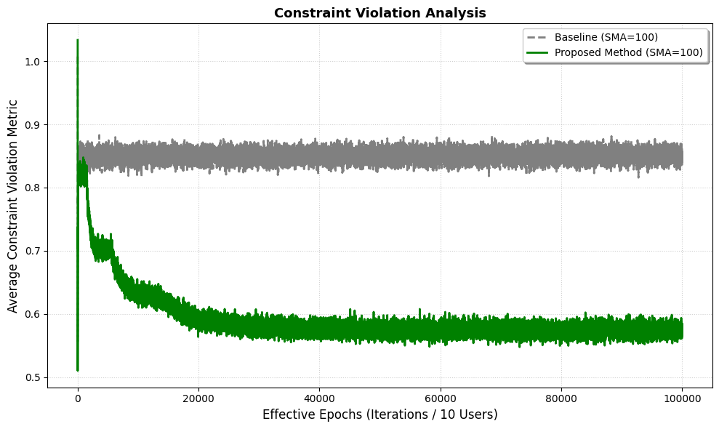
Fig 2: Comparison of constraint violation magnitude
The plot shows the Frobenius norm of capacity violations || max(0, Ax - b) || _ F over iterations. The proposed method (green solid line) significantly reduces violations, approaching a feasible solution, whereas the baseline method (gray dashed line) remains persistently infeasible. With Frobenius norm of constraint violation, defined as || max(0, Ax - b) || _ F, measures the aggregate magnitude of capacity exceeded across all users and time slots. Here, the term (Ax - b) represents the excess demand relative to the capacity. The max(0, .) operator ensures that only positive violations contribute to the error metric, while satisfied constraints are ignored.
With constraints included in the problem, the proposed method could deal with them by using dual approach and minimize the excess demand over epochs rather than keeping the excess demand stable likes the baseline approach.

Fig 4

Experiment 4: Sensitivity to Step Size
Goal: Determine the optimal step size for minimizing the objective function stably and quickly.

Figure 4: Sensitivity to Step Size - Objective Minimization
- Y-axis: Objective Value.
- Description: This plot shows the trajectory of the objective function for different step sizes.
  - High 0.02 (Red): Decreases rapidly but oscillates around the optimum.
  - Medium 0.002 (Green): Decreases smoothly and converges quickly to the minimum value $V^*$ (dashed line). This is the optimal choice.
  - Low 0.0002 (Blue): Decreases smoothly but is very slow to reach the minimum.
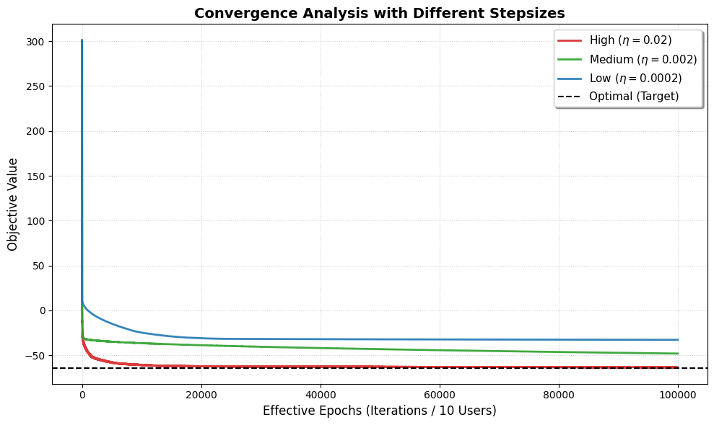
Fig 3. Sensitivity Analysis of Step Size
Considering this plot, the convergence behavior of the proposed Stochastic Gradient Descent (SGD) algorithm is highly sensitive to the choice of the step size. By tracking the Objective Function Value over 100,000 iterations. The performance is benchmarked against the optimal value V^* (represented by the black dashed line), which is obtained from the centralized solver (CVXPY). We compare three distinct step sizes: High (0.02), Medium (0.002) and Low (0.0002). Among these 3 step sizes, we select 0.02 as the operational step size for the proposed algorithm. It provides the most robust performance and makes the algorithm speedily reach the optimal objective value, in comparison with the medium (0.002) and low (0.0002) stepsizes, which converge much slower as shown on the figure.

Fig 1
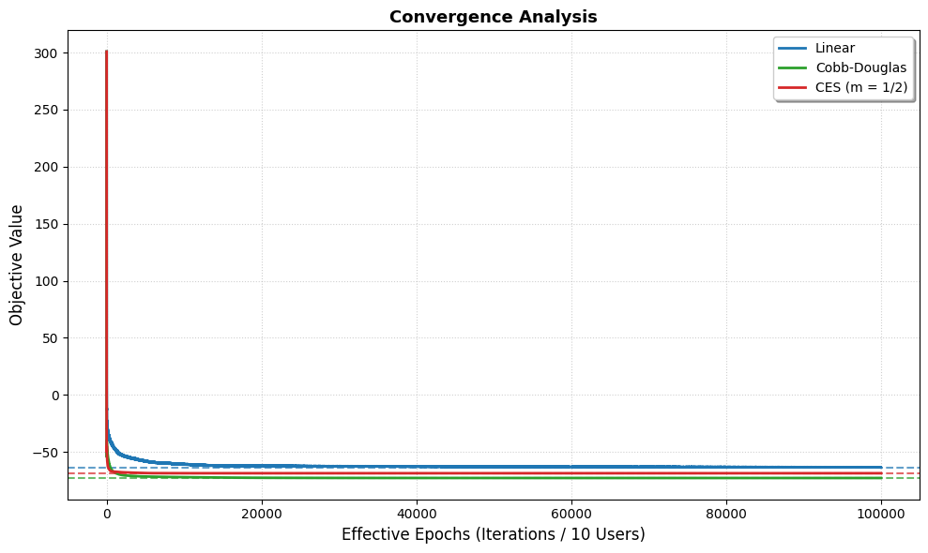
The plot demonstrates the proposed algorithm convergence ability. As shown on the figure, there are 3 different types of Homogeneous degree-1 functions chosen to be the utility function (Linear, Cobb-Douglas, CES (with m = 1/2)). By observing the objective value in each utility function over 100000 iterations, we can see that the algorithm converges as each the represented lines of each utility function (Blue for Linear, Green for Cobb-Douglas, Red for CES) reach the corresponding dashed lines (optimal value solved by centralized solver CVXPY).

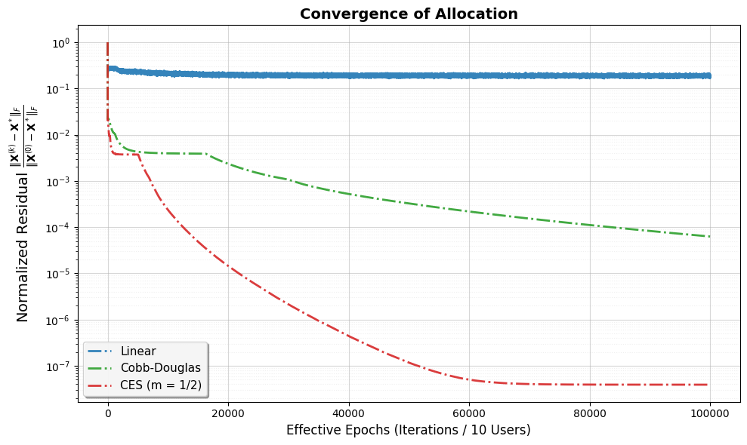
With the optimal allocation of the optimal value of centralized solver (CVXPY) denoted as X*, the initial allocation when the algorithm started to run denoted as X_0 and the allocation computed at the k-th iteration of the iterations denoted as X_k. We calculate || X_k - X* || _ F / || X_0 - X* || _ F. When the utility function is Cobb-Douglas or CES, we can see that this value decreases gradually from the first to the 100000th iterations, showing that the allocation the algorithm solves gradually becomes similar to the optimal allocation solved by the centralized solver. Meanwhile, the blue dashed line shows the stable pattern of sideways moving, meaning that the optimal allocation solved by the proposed algorithm might be different from the optimal allocation solved by the centralized solver (CVXPY). This aligns with the proposition that there are various optimal allocations when the utility function is Linear.

